

**LG TPC C 488 TICI 4 Ton**

**Rs. 204,999/-**

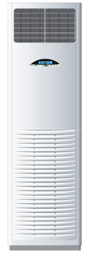

**Product Features**

* Low Noise Air Flow System
* Easy Clean Panel
* Remote Control Pocket
* Three Minutes Protection
* Rust Resistant Cabinet

**Specification**

**Type** Wall Mounted Split AC

**Cooling (Btu/h)** 43000

**Voltage (V)** 220-240

**Power Input (W)** 3800

**EER (Btu/W-h-W/W)** 6.6-2.5